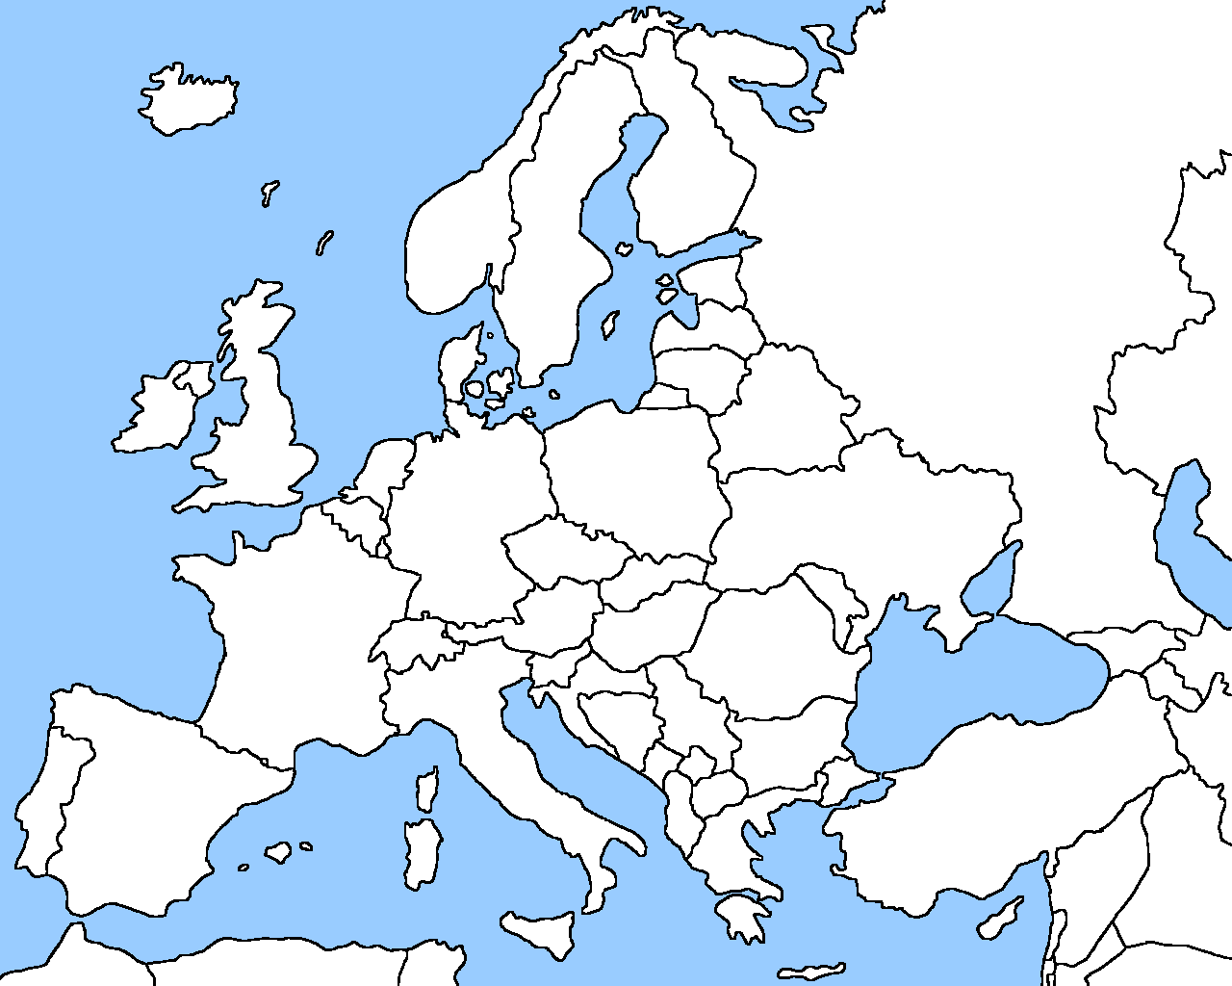

Ma

Mo

Serbia

**B-H**

**C**

**S[Type a quote from the document or the summary of an interesting point. You can position the text box anywhere in the document. Use the Drawing Tools tab to change the formatting of the pull quote text box.]**

Cyprus

Slovakia

Czech

Republic

Hungary

Austria

Moldova

Iceland

Belarus

Albania

**Finland**

Switzerland

Denmark

Romania

Bulgaria

Turkey

Poland

Latvia

Lithuania

Estonia

Luxembourg

Sweden

Norway

The   
Netherlands

Belgium

Spain

Ireland

Greece

Ukraine

Russia

Germany

United Kingdom

Portugal

Italy

France